EXPERIMENT- 24
Perform Sharpening of Image using High-Boost Masks
Aim
To write a Python code to sharpen an image using high-boost filtering technique in OpenCV for emphasizing high-frequency image components.
Input Image
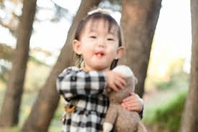

Code
import cv2
import numpy as np
from google.colab.patches import cv2_imshow
from google.colab import files
uploaded=files.upload()
image_path=list(uploaded.keys())[0]
image=cv2.imread(image_path)
if image is None:
print("Error: Image not found")
else:
blur=cv2.GaussianBlur(image,(5,5),0)
high_boost=cv2.addWeighted(image,1.5,blur,-0.5,0)
print("Original Image")
cv2_imshow(image)
print("High Boost Image")
cv2_imshow(high_boost)
Output Image
High Boost Sharpened Image
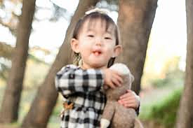
Result
Thus, the image was successfully sharpened using high-boost filtering in OpenCV.

